Name: ____________________

**What’s Going on Before and After the Illustration**

**Directions:** What’s going on in the illustration? Fill in the lines to tell the story of what’s going on in the image. Add an illustration to the Before box to show what could be happening before the illustration. Add writing to tell the part of the story just before the illustration. Then, add an illustration to the After box to show what could happen next. Finish by writing the story after the illustration. There are more lines on the back to continue the story.

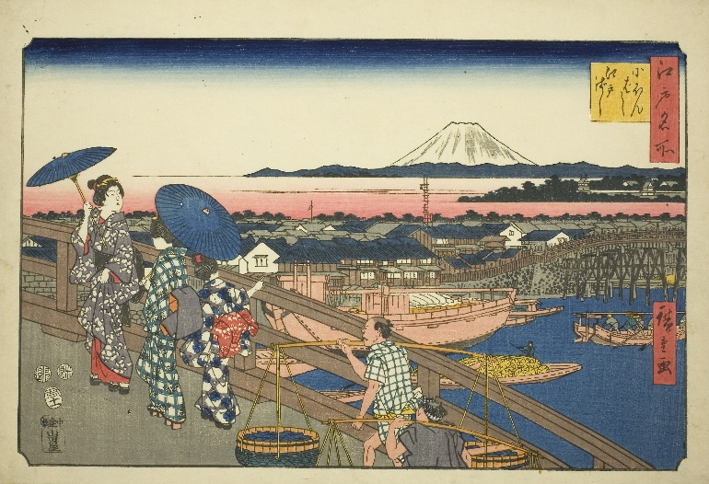 **Before During After**

_____________________________ __________________________________ ______________________________

_____________________________ __________________________________ ______________________________

_____________________________ __________________________________ ______________________________

_____________________________ __________________________________ ______________________________

_____________________________ __________________________________ ______________________________

_____________________________ __________________________________ ______________________________

_____________________________ __________________________________ ______________________________

**Before During After**

_____________________________ __________________________________ ______________________________

_____________________________ __________________________________ ______________________________

_____________________________ __________________________________ ______________________________

_____________________________ __________________________________ ______________________________

_____________________________ __________________________________ ______________________________

_____________________________ __________________________________ ______________________________

_____________________________ __________________________________ ______________________________

_____________________________ __________________________________ ______________________________

_____________________________ __________________________________ ______________________________

_____________________________ __________________________________ ______________________________

_____________________________ __________________________________ ______________________________

_____________________________ __________________________________ ______________________________

_____________________________ __________________________________ ______________________________

_____________________________ __________________________________ ______________________________

_____________________________ __________________________________ ______________________________

_____________________________ __________________________________ ______________________________

_____________________________ __________________________________ ______________________________

_____________________________ __________________________________ ______________________________

_____________________________ __________________________________ ______________________________

_____________________________ __________________________________ ______________________________